

Hadhramaut University

College of Computers & Information Technology

Department of Information Technology

**Online Medicine Ordering System Business**

**to Business**

A graduation project report submitted to the Department of Information Technology as partial fulfillment for the Requirements for the Degree of Bachelor of Science in Information Technology

**By**

Taha Abdullah Albar

Abddulqader Mohammed Shammakh

Ahmed Salem Bamehres

Mohammed Salah Bawazir

**Supervisor**

Dr. Engineer\Ibrahim Eskandar Ibrahim Fadhel

**August 2022**

**Abstract**

Pharmaceutical practices have evolved over time to become fully encompassed in all aspects of pharmacy itself. Such practices include: dispensing of drugs, consultation, drug regulation, and the sale of these drugs. The community pharmacies and hospital pharmacies have key roles to play in the pharmaceutical practices.

For the community pharmacies in Mukalla, a strict approach to the sale and dispensation of drugs is not normally the case. There is a need for these practices to be fully enforced, and a management system introduced to the fray. With software such as the Online Pharmaceutical Management System, which provides a platform has been provided to help with drug regulation, as well as providing ease to all parties involved. Creating an Online Pharmaceutical Management System would help in pharmaceutical practices for all parties involved. It is eminent that the system provides a safe, secure and verified platform for all parties which help to bridge the communication gap and provide legitimate drugs.

**الخلاصة**

تطورت الممارسات الصيدلانية بمرور الوقت لتصبح مشمولة بالكامل في جميع جوانب الصيدلة نفسها، وتشمل هذه الممارسات: الاستغناء عن الأدوية، الاستشارة وتنظيم البيع.

تلعب صيدليات المجتمع وصيدليات المستشفيات أدوارًا رئيسية في ف الممارسات الصيدلانية فبالنسبة لصيدليات المجتمع بالمكلا، لا يوجد نهج صارم للبيع وصرف الأدوية عادة وهناك حاجة لتطبيق هذه الممارسات بشكل كامل، وإدخال نظام إدارة لهذه المعركة.

استخدام برنامج مثل نظام إدارة المستحضرات الصيدلانية عبر الإنترنت، يوفر نظامًا أساسيًا للمساعدة في تنظيم الأدوية، فضلاً عن تيسير العمل لجميع الأطراف المعنية.

من شأن إنشاء نظام إدارة صيدلانية عبر الإنترنت أن يساعد في الممارسات الصيدلانية لجميع الأطراف المعنية ومن الجدير بالذكر أن النظام يوفر منصة آمنة وموثوقة لجميع الأطراف مما يساعد على سد فجوة الاتصال وتوفير الأدوية المشروعة.

**Dedication**

We students provide dedication to our parents who helped us in our educational journey, and urged us to continue education, and they were supporting us financially and morally, and also, we offer to dedicate this work to the teachers and doctors to support us and their keenness to communicate information to us, as well as we offer the dedication of this work to colleagues and all those who stood with us and supported us during the educational process.

**Acknowledgment**

After this great effort which combined with blessing of Allah we would like firstly to thank so much our supervisor: Dr. Engineer\ Ibrahim Eskandar Ibrahim Fadhel for his great efforts, advices and guidance.

Thank you to those who contributed and give the hand of help to us during the project time. Glory be to Allah for his blessing in our project by allowing us to cooperate professionally, participating effectively together to successfully accomplish the project.

**Table of Contents**

|  |  |
| --- | --- |
| **Title** | **Page No.** |
| Abstract | i |
| الخلاصة باللغة العربية | ii |
| Dedication | iii |
| Acknowledgment | iv |
| Table of Contents | v |
| List of Tables | vii |
| List of Figures | viii |
| List of Abbreviations | ix |
| **Chapter 1: Introduction** | 1 |
| 1.1 Introduction | 2 |
| 1.2 Problem Statement | 2 |
| 1.3 Project Objectives | 2 |
| 1.4 Project Scope | 3 |
| 1.5 Project Methodology | 3 |
| 1.6 Tools & Programing Languages | 3 |
| 1.7 Organization of the Project | 4 |
| **Chapter 2: Background & Related Works** | 5 |
| 2.1 Introduction | 6 |
| 2.2 Background | 6 |
| 2.2.1 Main Concepts of the Project | 6 |
| 2.2.2 Application Work Procedures | 7 |
| 2.3 Related Works | 8 |
| **Chapter 3: Analysis & Design** | 10 |
| 3.1 Introduction | 11 |
| 3.2 System Analysis | 11 |
| 3.2.1 Requirements Gathering | 11 |
| 3.2.2 System Users | 11 |
| 3.2.3 System Requirements | 12 |
| 3.2.4 Use Case Diagram & Scenario | 14 |
| 3.2.5 Class Diagram | 21 |
| 3.3 System Design | 23 |
| 3.3.1 Entity Relationship Diagram | 23 |
| 3.3.2 Database Diagram | 26 |
| 3.3.3 Details of the Database Tables | 27 |
| **Chapter 4: Implementation & Findings** | 30 |
| 4.1 Introduction | 31 |
| 4.2 Hardware and Software Specifications | 31 |
| 4.3 Development Tools and Languages | 31 |
| 4.4 Interfaces | 32 |
| **Chapter 5: Conclusion & Future Work** | 40 |
| 5.1 Introduction | 41 |
| 5.2 Conclusion | 41 |
| 5.3 Future Work | 41 |
| **Reference** | 42 |

**List Of Tables**

**Table Page number**

Table (1) Functional requirements. . . . . . . . . . . . . . .. . . . . . . . . . . . . . . . . . . . . . . .12

Table (2) Sign Up. . . . . . . . . . . . . . . . . . . . . . . . . . . . . . . . . . . . . . . . . . . . . . . . . . .17

Table (3) Login. . . . . . . . . . . . . . . . . . . . . . . . . . . . . . . . . . . . . . . . . . . . . . . . . . . . .17

Table (4) View Item. . . . . . . . . . . . . . . . . . . . . . . . . . . . . . . . . . . . . . . . . . . . .. . . . .18

Table (5) Manage Products. . . . . . . . . . . . . . . . . . . . .. . . . . . . . . . . . . . . . . . . . . . . 19

Table (6) Tracking Order. . . . . . . . . . . . . . . . . . . . . . . . . . . . . . . . . . . . . . . . . . . . .19

Table (7) Manage Orders. . . . . . . . . . . . . . . . . . . . . . . . . . . . . . . . . . . . . . . . . . . . . 20

Table (8) ERD Description. . . . . . . . . . . . . . . . . . . . . . . . . . . . . . . . . . . . . . . .. . . . 23

Table (9) User Tables. . . . . . . . . . . . . . . . . . . . . . . . . . . . . . . . . . . . . . . . . . . . . . 27

Table (10) Category Tables. . . . . . . . . . . . . . . . . . . . . . . . . . . . . . . . . . . . . . . . . . . 27

Table (11) Items Tables. . . . . . . . . . . . . . . . . . . . . . . . . . . . . . . . . . . . . . . . . . . . . . 28

Table (12) Order Tables. . . . . . . . . . . . . . . . . . . . . . . . . . . . . . . . . . . . . . . . . . . . . 28

Table (13) Order Details Tables. . . . . . . . . . . . . . . . . . . . .. . . . . . . . . . . . . . . . . . . 29

**List Of Figures**

**Figure Page number**

Figure (2-1) Dashboard of apollopharmacy .. .. . . . . ... . . . . . . . .. . . . . . . . . . . 9

Figure (3-1) Use Case Diagram. . . . . . . . . . . . . . . . . . . . . . . . . .. . . . . . . . .. . 16

Figure (3-2) Class Diagram (Repository). . . . . . . . . . .. . . . . . . . . . . . . .. . . .. 21

Figure (3-3) Class Diagram (Models). . . . . . . . . . . . . . . . . . . .. . . . . . . . . . .....22

Figure (3-4) ERD Diagram . . . . . . . . . . . . . . . . . . .. . . . . . . . . . . . . . . .. ... … 25

Figure (3-5) Database Diagram . . . . . .. . . . . . . . . . . . . . .. . . . . . . . . . . . . . . . 26

Figure (4-1) Admin Dashboard Page **. . . . . . . . . . . . . . . .. . . . . . . . . . . .. . . . . . . . . . . . ..** 32

Figure (4-2) Admin User page**. . .. . . . . . . . . . . . . . . . . . . . . . . . . . . . . . .. . . . . . . . . . . . ..** 33

Figure (4-3) Admin Orders Page**. . .. . . . . . . . . . . .. . . . . . . . .. . . . . . . .. . . .. . . . .. . . . . ..** 33

Figure (4-4) Admin Item Page **. . .. . . . . . . . . . . .. . . .. . . . . . . . . . . . . . . .. . . . . . . . . . . . ..** 34

Figure (4-5) Admin Add Item Page . .. . . .. . . . . . . . . . . . . . . . . . . . . . . . . . . 34

Figure (4-6) Admin Category Page . . . . . .. . . . . . . . .. . . . .. . . . . . . . . . . . . 35

Figure (4-7) Admin Add Category Page. . . . . . . . . . . . . . . . . . . . . . . . . . .. . 35

Figure (4-8) Registration Page. . . . . . . . . . . .. . . . . . .. . . . . . .. . . . . . . . . . 36

Figure (4-9) Log in Page. . . . . . . . . . . . . . . .. . . . . . . . . . . . . . . . . .. . . . . . . 36

Figure (4-10) Home Page. . . . . . . . . . . . . . . . . . . . . . . . . .. . . . . . . . . . . . . . 37

Figure (4-11) Item Details Page. . . . . . . . .. . . . . . . . . . . . . . . . . . . . . . . . . . . 37

Figure (4-12) Cart Page. . . . . . . . . . . . . . . . . . . .. . . . . . . . . . . . . . . . .. . . . . 38

Figure (4-13) Shopping Page. . . . . . . . .. . . . . . . . . . . . . . . . . . . . . . . . . . . . . 38

Figure (4-14) Track Order Page. . . . . . . .. . .. . . . . . . . . . . . . . . . . . . . . . . . . .39

**List of Abbreviations**

|  |  |
| --- | --- |
| **Symbol** | **Meaning** |
| B2B  MVC  ASP  SQL  HTML  CSS | business to business  Model-View-Controller  Application Service Provider  Structured Query Language  Hyper Text Markup Language  Cascading Style Sheets |
|  |  |

**Chapter 1**

**Introduction**

* 1. **Introduction**

Average Mukalla people spend a significant amount of income on medicine. A

reliable and fast online medicine system is not ubiquitous. Most people specially

the pharmacists buy medicine from the local Pharmacies. They need to go to

medicine stores to buy the specific medicine prescribed. Sometimes all medicines

are not available in local Pharmacies (store) therefore people need to go to other

areas to buy the medicines. This project presents the development of a web based

online medicine system (business to business). A reliable, fast, safe and user friendly online based e-commerce web application will be developed in this

project.

**1.2 Problem Statement**

Taking a look at Mukalla in general, the online pharmaceutical field is relatively

underdeveloped and an untapped one. The available systems have not fully

captured the essence of a pharmaceutical inventory system. In view of the

foregoing, this research work aims to rectify this problem by providing the

platform for the ever-growing pharmaceutical industry in the country, and region

as a whole.

* 1. **Project Objectives**

The proposed system aims to connect and serve as an intermediary between  
pharmacists (B2B) and drug manufacturers, through a platform that allows the order of drugs with the click of a button, and simultaneously keeps track of what drugs have been ordered and in what quantity and is short in tow:

* The system is achieved B2B system for deal of that.
* Facilitate Pharmaceutical Purchase on system from manufacturing

**1.4 Project Scope**

This project is about a grouping company targeting pharmacies in terms of purchasing operations, which distances them from the traditional way of purchasing. So that makes them order products easier and faster. It does not include arithmetic operations such as ledger, posting and dealing with different currencies, and does not include credit, debit, depreciation and other aspects. This project will be implemented geographically in Mukalla, Yemen. It takes four months - six months to complete.

**1.5 Project Methodology**

This project categorized as a quantitative approach, an agile approach was used to complete this project. As this is a complete online website the approach that was used in the design of the system is Incremental Model of System Development Life Cycle where the product being designed is implemented and tested incrementally. It is relatively cheap and is used for small projects. This methodology is most suitable for the project due to the project’s future requirements which would require changes in the system [1].

**1.6 Tools & Programing Languages**

The system services that used in our project that started working with building

the database, linking the Relationships and management by SQL Server and to

create the interfaces of the project using adobe XD.

Finally, we finished the work by building Back-End using C# programming

language with its framework ASP.NET Framework MVC for the Client side

and Server side by Visual Studio Code.

**1.7 Organization of the Project**

In the chapter " Background & Related Works" we will talk about a  
brief overview of pharmacology and its importance and what is to be  
done in the side of medicine, we talked about some of the related  
works similar to our project and we mentioned the advantages and  
disadvantages of each.

In the System Analysis chapter, we have drawn the analytical and engineering drawings of the databases and processes in our project using UML (Use Case, Database, ERD Diagram) with an explanation  
of those graphics. Store and project dashboard. In the “final chapter”  
we discussed the results and compared them with the goals we  
mentioned to what extent those goals were achieved, then we  
mentioned their shortcomings, we mentioned our suggestions in the  
future work part, and what are the suggestions that would improve the  
project

**Chapter 2**

**Background & Related Works**

* 1. **Introduction**

The practice of pharmacy involves the general implementation of medical orders which entail the evaluation and the interpretation of the medical orders, the administration of drugs, dispensation of prescribed drugs from qualified medical practitioners, the review of prescribed drug regimen, and the correct storage of drugs [2].

The American Pharmacists Association has described pharmacy as having a mission which is the responsibility of ensuring the use of medication in the right way and manner, and enjoying the services of drugs to ensure the achievement of optimized results in therapeutic applications.

In addition, the birth of modern pharmacy has brought with it some positive effects in the society; like the increase in life expectancy globally from 45 years to 50 years, which some argue is as a result of the number of breakthroughs recorded in pharmacy over the last century. These breakthroughs such as: the discovery of new compounds in battling existing ailments and the invention of methods and devices to accurately

dispense drugs have been welcomed with open arms by the society.[3].

* 1. **Background**

**2.2.1** Main Concepts of the Project:

The growing popularity of computers and gadgets in general has in no way  
slowed down the birth of new innovative ways in the pharmaceutical  
management system. These days, computers have become an essential part  
of many people’s lives due to the versatility of the devices, and how much  
they can do with so little effort. Performing tasks which would have taken  
hours and maybe days in the past, have become possible in seconds. The  
invention of the Internet and other utilities such as search engines (Google  
being a prime example), have made searching for the most remote things  
possible in very little time. Also, the portability of the computer systems  
has helped the cause in making information more portable than it was in  
the past. In the same vein, the management of inventory and taking stock  
of goods and services in different organizations have become so much  
easier with the growth of the computer system (Goldberg et al, 1991).  
These days, even phones and tablets have faster processing power than the  
early generation computers, which has made it easier to perform tasks. Our  
economy has been referred to as the “learning economy”, because of the  
rate at which new innovations come to light [1]. In China, a text message system was developed to help in general  
patient pharmaceutical care, and promote mobile [4].

**2.2.2** Application Work Procedures:

Medicine system this platform is a dynamic web application built in C#  
based on ASP.NET MVC frame-work. This system is lightning fast and  
optimized very well for searching engines. With the help of the developed  
platform, drugs will be available at one’s doorstep very fast, safely and  
reliably. In this system, users can choose a medicine section of their  
choices and go through all the items that the system provides. Users can  
then select the desired drug items, add them to cart and then proceed to  
payment. Due to the huge demand of online medicine delivery system there  
are very few companies that have recently started e-commerce based  
online medicine delivery services. Our system is one of the online  
aggregation company in Mukalla that provides medicine and generic  
products. It is very simple and easy as well to use this web application. The first important advantage is the ability to quickly find the necessary medical  
products, using a search bar. The search menu option has been integrated  
with our platform to make the products searching very fast. Price of  
Products will be competitive on our platform. Our system will have a huge  
customer database and in future we can apply big data analysis and  
machine learning algorithms based on customers review to attract more  
new customers and retain older customers. An online medicine system is  
an online based web application that operates over the Internet and reserves  
orders to customers. People can buy and sell their products sitting at home.  
It is getting popular day by day all over the region even in domestic market  
space. The aim is to make the ordering process systems of medicines much  
easier and customer-friendly. It’s very important to make a user-friendly  
environment.

* 1. **Related Works**

**2.3.1 apollopharmacy.in** [5]

Apollo pharmacy is an Indian e-pharmacy that help Indian  
people to buy medicines and healthcare products also many  
other medical products, they describe a helpful information  
of products. It’s a huge web application that also provides many  
services to customers They didn't offer the ability to tracking orders for the  
user. like online doctor consultation and online pro health programs.

Advantages:

* Provide a wide list of products to users
* Use excellent categories of products.
* Provide helpful information about products.
* Provides an online doctor consultation.

Disadvantage:

* They didn't offer the ability to tracking orders for the user
* A limited number of products for some packages.

Interfaces:

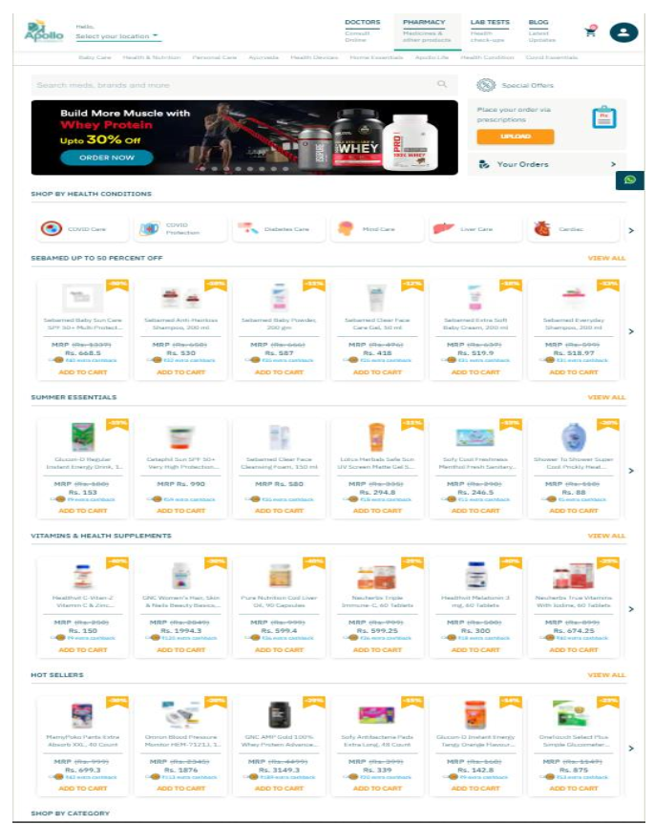

Figure 2.1: Dashboard of apollopharmacy.

So, in our project, we are focus to build an easy tool for local and small enterprises  
to provide the tracking orders which is used to manage the enterprise and provide  
the enterprise with an electronic store in order to keep pace with technical  
development

**Chapter 3**

**Analysis & Design**

**3.1 Introduction:**

This chapter explains the data collection & design processes from how the data was collected to the final system designs along with the system design  
methodology and information needs that produces functional requirements i.e., collection of tools methods and practices for achieving a task; the requirement specification states the expectation of the system analysis, and design which is the blueprint of what the system would carry out.

**3.2 System Analysis:**

**3.2.1** Requirements Gathering:

The process starts with good sources by Identify the relevant stakeholders' (pharmacists) users by Face-to-face individual interviews to make an effort to understand and experience the user's problem to describe it clearly and correctly. And we about their jobs and the problems to understanding of the work environment We also Study analogous systems as apollopharmacy.in to get of good ideas for solving user problems and we Conduct a brainstorming session More than one to Make sure the requirements clearly capture what was intended.

**3.2.2** System Users:

1. Admin: has access for all functionality of the system from managing items to managing orders and so on.
2. Registered customer: can search for items, get details and make an order**.**
3. Unregistered customer: can search for items and get details only.

**3.2.3 System Requirements:**

**3.2.3.1 functional requirements:**

Table 1: functional requirements

|  |  |  |  |
| --- | --- | --- | --- |
| Function | Input | Output | Constraint |
| Sign Up | Enters information (Full Name –Licenses - Username -Password -Email -Address -Phone Number) | -Receive an email containing code number | -User Name must be start with capital letter -Password should be at least of 6 length -Ensure password are matching in both fields -Ensure email entered correctly -Phone number must be only of 9 digits |
| Verification | -Enters code number | -Sign up successfully -Access to home page for customer |  |
| Login | -Enter Username and Password | - Access to home page for customer or Control page for Admin and employee | -Validation of all fields |
| Forget password | -Enter your email -Enter code number -Enter new password | -Receive an email containing code number - Redirect to new password page -Save new password | -Ensure email entered correctly -Password should be at least of 6 length |
| View Item | -Clicks any product that will open an information page of that item. | -Show all items that added by admin. -Show and obtain the more information about item | - |
| Search for Item | -Search for Specific item by its name | -Obtain the items stored as you write | - |
| Add to cart | -Select an item that you need bay it. | -Add and store all selected item s in your cart | -Username must be login |
| Track Order | -Click on Track order button | -Show the detail about receive order such as date of access | -Username must be login |
| Display Cart | - | Show all items in your cart | -Username must be login |
| Send to bay | -After Confirm the item that he needs for a purchase | -Send to bay | -Username must be login |
| Remove Item | -Click on Remove button to Remove item from website. | -The item was deleted and decrease the list of items | -Username must be login |
| Manage Products (Add products) | -Click to add item and its details | -Add and store all items and its details | -Username must be login |
| Manage Products (Update details products) | -Change and update new details or info of item | -Save and store new details or info of item successfully | -Username must be login |
| Display Orders (Manage Orders) | - | - | -Username must be login |
| Accept Order | -Check the orders | -Send a message to the customer informing when his order will be delivered | -Username must be login |

**3.2.3.2 Nonfunctional requirements:**

1-The website’s load time should not be more than one second for users.

2-Applicants can access their resume 98% of the time without failure.

3-Admin can post items on the website throughout the week at any time during the day. In the case of unplanned system downtime, all features will be available again after one working day.

4-Up to 500 applicants can request for a resume review. Up to

1,000,000 resumes can be stored.

-Security: Only the users with the role “site admin” can view the

applicant’s verified phone number.

-Manageability: When editing the code for applicants’ profile pages, the rest of the site stays up and running.

-Usability: The website’s interface has to be user-friendly and easy to use

**3.2.4 Use Case Diagram & Scenario**

A use case diagram at its simplest is a representation of a user's interaction with the system

## Basic Use Case Diagram Symbols and Notations :

1. **System**  
   Draw your system's boundaries using a rectangle that contains use cases. Place actors outside the system's boundaries.

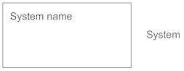

1. **Use Case**  
   represent the system's functions.

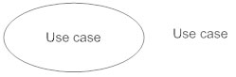

1. **Actors**  
   Actors are the users of a system.

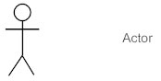

1. **Relationships**  
   The relationships between an actor and a use case with a simple line.

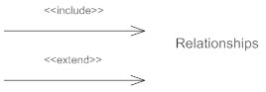

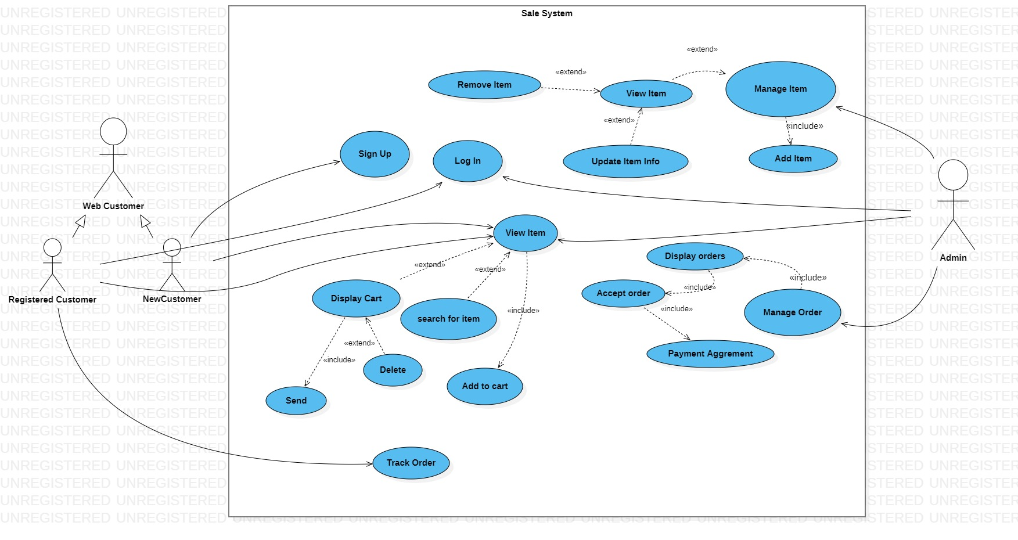.

Figure 3.1: Use Case Diagram

Table 2: Sign Up

|  |  |
| --- | --- |
| Use case Number: | UC-01 |
| Use Case Name: | Sign Up |
| Overview: | Customer register as new Account in system |
| Actor(s): | New Customer |
| Normal Flow: | 1. Open Browser and enter our site2. Customer Clicks Sign Up3. The Customer Enters information like: Username, Password, Email, mobile4. The Customer Clicks Sign Up button5. If the information is correct, a Home page appears and he is logging |
| Alternate Flow | 5.1. Error Message(s) appear(s) in same page(Sign Up) |

Table 3: Login

|  |  |
| --- | --- |
| Use case Number: | UC-02 |
| Use Case Name: | Login |
| Overview: | Login to the system |
| Actor(s): | 1-Registerd Customer2-Admin |
| Normal Flow: | 1. Open Browser and enter our site2. Actors Click login3. The Actors Enter Password and Email4. The Actors Click login button5. If the information is correct the Home page appears for customer or Control page for Admin and employee |
| Alternate Flow | 5.1. Error Message(s) appear(s) in samepage(login) |

Table 4: View Items

|  |  |
| --- | --- |
| Use case Number: | UC-03 |
| Use Case Name: | View Item |
| Overview: | Show list of products |
| Actor(s): | 1-Registerd Customer2-Admin3-New Customer |
| Normal Flow: | 1. The Actor will see list of products (picture, title, cost). 2. The actors can search for any specific item  by name then he can display its information. 3. When Actor clicks any product that will  open an information page of that product,  and he will be able to add it to cart if he’s  logged in to his account. 4. The actor can display his cart by press cart  button if he logged in, also he can increase  quantity of items of the cart and delete it  from the same place. |
| Alternate Flow | 3.1. If actor not logged in, he will not be able to display or add product to cart and the system will redirect him to login page. a. If actor not logged in, he will not be able to display the cart and the system will redirect him to login pag**e** |

|  |  |
| --- | --- |
| Use case Number: | UC-04 |
| Use Case Name: | Manage Products |
| Overview: | Admin mange product |
| Actor(s): | Admin |
| Normal Flow: | 1. Admin must be logged in.2. Admin clicks "products" in Control page.3. In this page the admin will see list ofproducts.4. Admin can add, delete, edit product. |
| Alternate Flow | 1.1. If customer not logged the system willredirect him to login page4.1. Error Message(s) appear(s) in same page |

Table 5: Manage Item

Table 6: Track Order

|  |  |
| --- | --- |
| Use case Number: | UC-05 |
| Use Case Name: | Tracking Order |
| Overview: | Customer tracking his order |
| Actor(s): | Customer |
| Normal Flow: | 1. Customer must be logged in.2. In **My cart page** The Customer clicks.“Tracking My Orders” Button, The **Tracking Order** Page appears.3. Customer can check the status of his order andwhere it become at ordering cycle, he can see ifthe order confirms or if delivered or not, alsowhat time need to get the order. |
| Alternate Flow | 1.1. If customer not logged the system willredirect him to login page3.1. Error Message(s) appear(s) in same page |

Table 7: Manage Orders

|  |  |
| --- | --- |
| Use case Number: | UC-06 |
| Use Case Name: | Manage Order |
| Overview: | Admin manage submitted orders |
| Actor(s): | Admin |
| Normal Flow: | 1. Admin must be logged in2. Admin clicks "Orders" in Control page3. In this page the admin will see list of orders.4. Admin can display order by click on it.5. In this page Admin can accept any order fromusers after checks payment voucher.6. Admin can report orders. |
| Alternate Flow | 1.1 If Admin not logged the system will redirecthim to login page |

**3.2.5 Class Diagram**

A class diagram is one of the most common types of systems used to  
illustrate, clarify and describe the structure of a system by clarifying  
classes, features and relationships between classes and their properties.

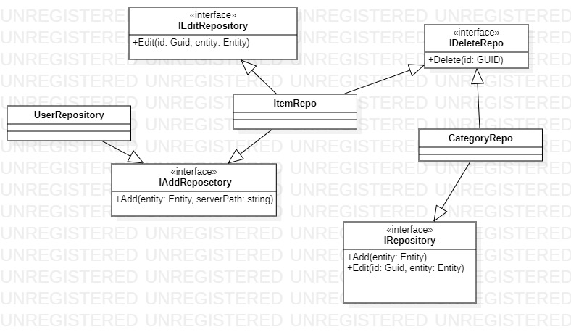

Figure 3.2: Class Diagram (Repository)

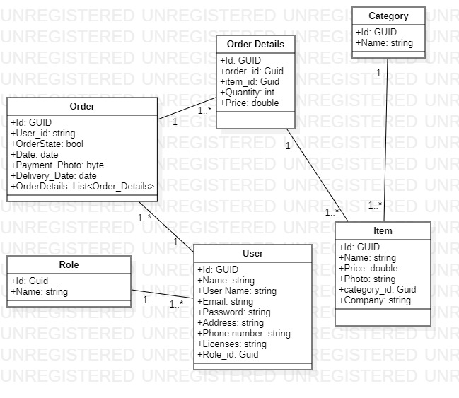

Figure 3.3: Class Diagram (Models)

**3.2 System Design**

**3.3.1 ERD Diagram**

Table 8: ERD Description

An entity relationship diagram (ERD) shows the relationships of entity sets stored in a database.[6]

|  |  |  |
| --- | --- | --- |
| Symbol**s** | Name | Description |
| Strong Entity Symbol | Strong entity | is the one whose existence does not depend on the existence of any other entity in a schema. |
| Weak Entity Symbol | Weak entity | Weak Relationships are connections between a weak entity and its owner. |
| Relationship Symbol | Relationship | Relationships are associations between or among entities. |
| Weak Relationship Symbol | Weak relationship | Weak Relationships are connections between a weak entity and its owner. |
| Attribute Symbol | Attribute | Attributes are characteristics of an entity, a many-to-many relationship, or a one-to-one relationship. |
| Multivalued Attribute Symbol | Multivalued attribute | Multivalued attributes are those that are can take on more than one value. |
|  | Derived attribute | Derived attributes are attributes whose value can be calculated from related attribute values |
|  | composite attribute | is an attribute where the values of that attribute can be further subdivided into meaningful sub-parts |

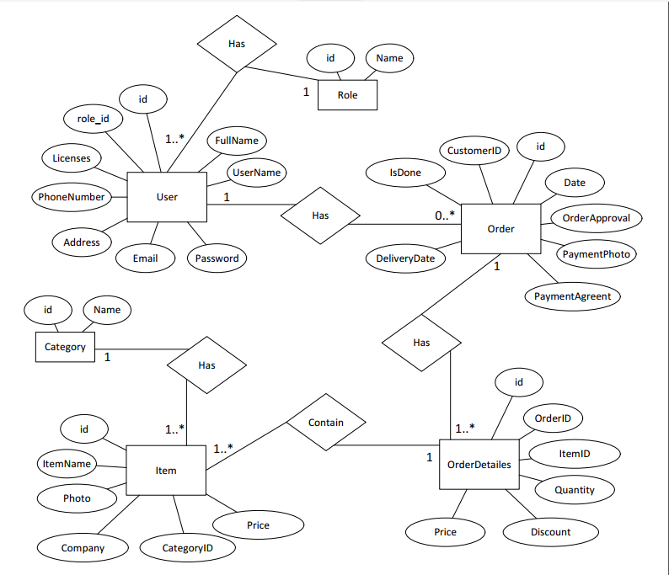

Figure 3.4: Entity Relationship Diagram

**3.3.2 Database Diagram**

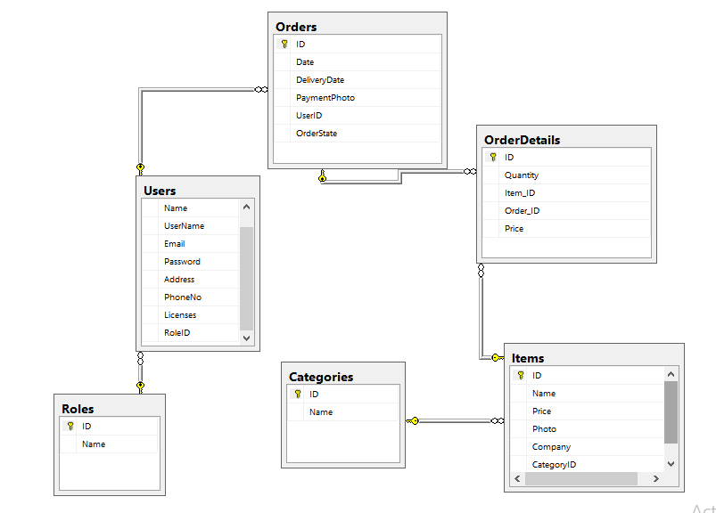Database diagrams graphically show the structure of the database and relations between database objects. You can generate a diagram for a data source, a schema, or a table. To create relations between database objects, consider using primary and foreign keys

Figure 3.5: Database Diagram

**3.3.3 Details of the Database Tables**

Database Tables is to show the details of tables in database and data elements of every table and the data type of it with clear details.

Table 9: User Tables

|  |  |  |  |
| --- | --- | --- | --- |
| NO. | Filed Name | Data Type | Description |
| 1. | User_Id | nvarchar (50) | This is the primary key of customer (each user only has unique number) |
| 2. | FullName | nvarchar (50) | This is the full name of user |
| 3. | Licenses | nvarchar (50) | This is the licenses of user that must be owned when open its pharmacy |
| 4. | UserName | nvarchar (50) | This is the user name of user that will enter to our website |
| 5. | Password | nvarchar (50) | This is the user password of user that will enter to our website |
| 6. | Email | nvarchar (50) | This is the email of user |
| 7. | Address | nvarchar (50) | This is the address of user |
| 8. | PhoneNumber | int | This is the phone number of users |

Table 10: Category Tables

|  |  |  |  |
| --- | --- | --- | --- |
| NO. | Filed Name | Data Type | Description |
| 1. | Category_Id | nvarchar (5) | This is the primary key of category )each category only has unique number) |
| 2. | Name | nvarchar (50) | This is the category name of items |

Table 11: Items Tables

|  |  |  |  |
| --- | --- | --- | --- |
| NO. | Filed Name | Data Type | Description |
| 1. | Item_Id | nvarchar (5) | This is the primary key of item (each item only has unique number) |
| 2. | ItemeName | nvarchar (50) | This is the name of item |
| 3. | ItemPrice | double | This is the final price of item |
| 4. | CompanyName | nvarchar (50) | This is the category name of items |
| 5. | Category_Id | nvarchar (5) | This is the primary key of category table (it called foreign key and this shows the relationship between item and category tables |
| 6. | Type_Id | nvarchar (5) | This is the primary key of type table (it called foreign key and this shows the relationship between item and type tables |
| 7. | ItemPhoto | nvarchar (50) | This is the picture of item |

Table 12: Order Tables

|  |  |  |  |
| --- | --- | --- | --- |
| NO. | Filed Name | Data Type | Description |
| 1. | Order_Id | nvarchar (5) | This is the primary key of order (each order only has unique number) |
| 2. | Date | datetime | This is the date and time of order |
| 3. | Order_approval | bit | This is the approval that do by admin |
| 4. | payment_photo | nvarchar (50) | This is the picture of payment process (transfer or deposit) |
| 5. | DeliveryData | nvarchar (50) | This is the data of the delivery |
| 6. | is_done | bit | This is the receipt confirmation by customer |
| 7. | Customer_Id | nvarchar (5) | This is the primary key of customer table (it called foreign key and this shows the relationship between order and customer tables) |

Table 13: Order Details Tables

|  |  |  |  |
| --- | --- | --- | --- |
| NO. | Filed Name | Data Type | Description |
| 1. | Id | nvarchar (5) | This is the primary key of order detail (each order detail only has unique number) |
| 2. | Order_Id | nvarchar (5) | This is the primary key of order table (it called foreign key and this shows the relationship between order and item tables) |
| 3. | Item_Id | nvarchar (5) | . This is the primary key of order table (it called foreign key and this shows the relationship between item and order tables) |
| 4. | Quantity | int | This is the quantity of items that customer needs them. |
| 5. | Discount | nvarchar (50) | This is the discount on price of item |
| 6. | Price | double | This is the final price of item |

**Chapter 4**

**Implementation & Findings**

1. **Introduction:**

The Translate of design that have the thing that is Implementation of it from the final project from the specification of where the project is run and need and the development tool and langue that is used to findings and the job is complete and consider and compare between the analysis and design for objectives and result.

1. **Hardware and Software Specifications:**

The hardware is specific on used internet connection by laptop or desktop devises or smart phone the point is can access internet also about software in any platform must be have browser at it to open website.

1. **Development Tools and Languages:**

* C# language using Asp.Net Framework.
* Html, CSS and java script
* SQL database
* Visual Studio 2019
* SQL Server 2017
* Adobe XD

1. **Interfaces:**

* **Admin Dashboard Page:**

In this page the admin or employee have full control and see the statistics of our system, and can see the Users is registered and manage it and items for add new items and edit and categories for mange it and orders to ,ack acceptable of it.

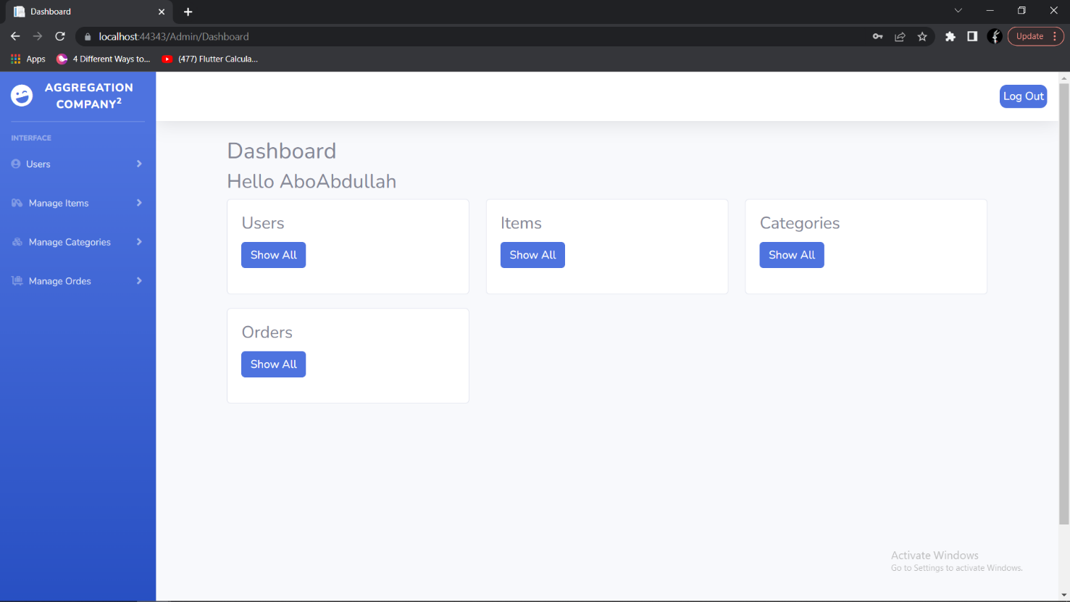

Figure 4.1: Admin Dashboard Page

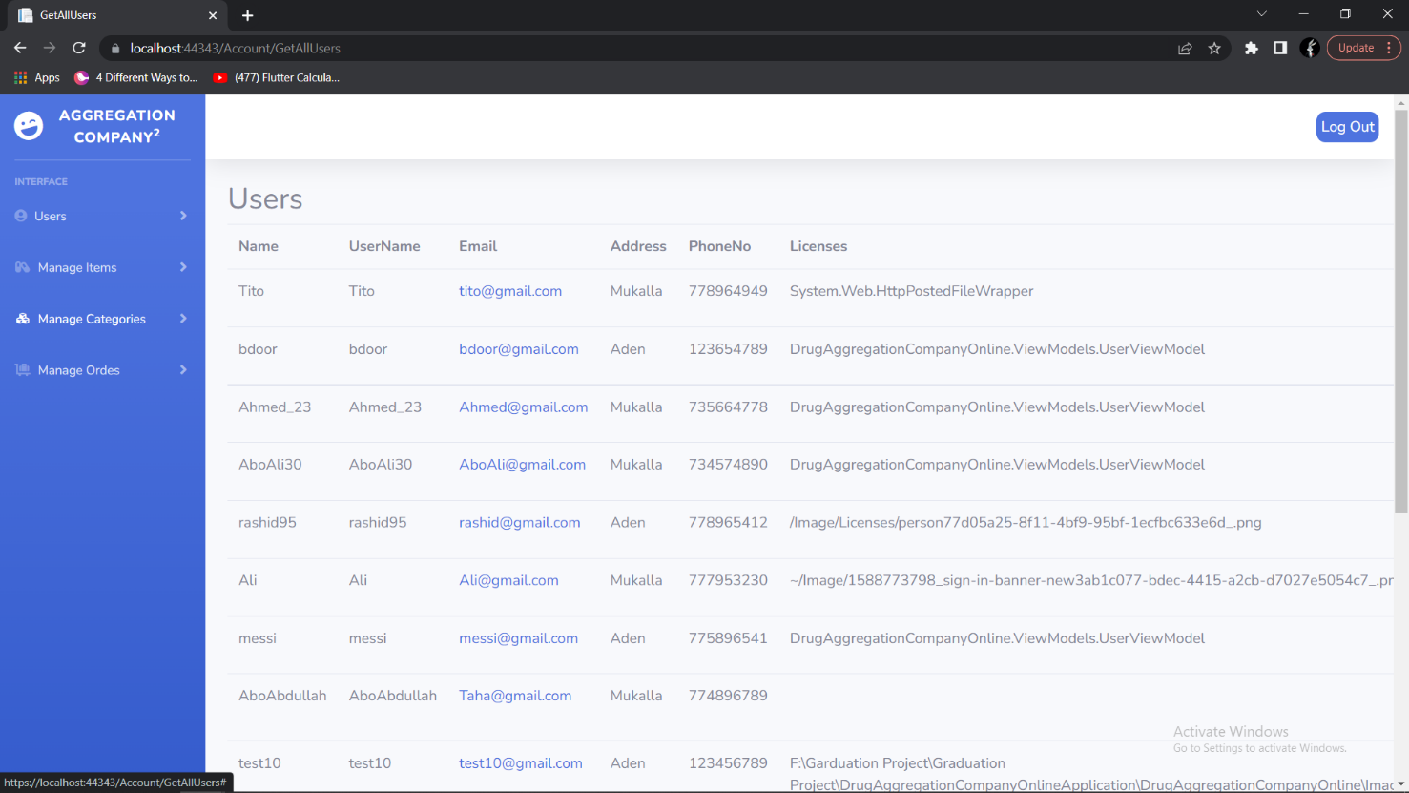

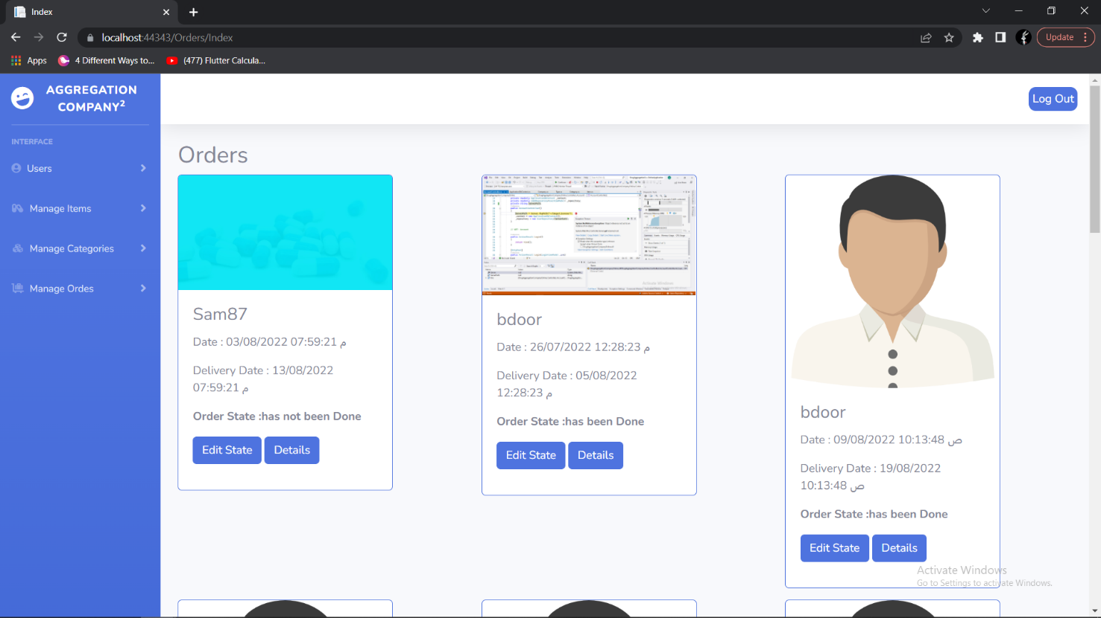Figure 4.2: Admin User page

Figure 4.3: Admin Orders Page

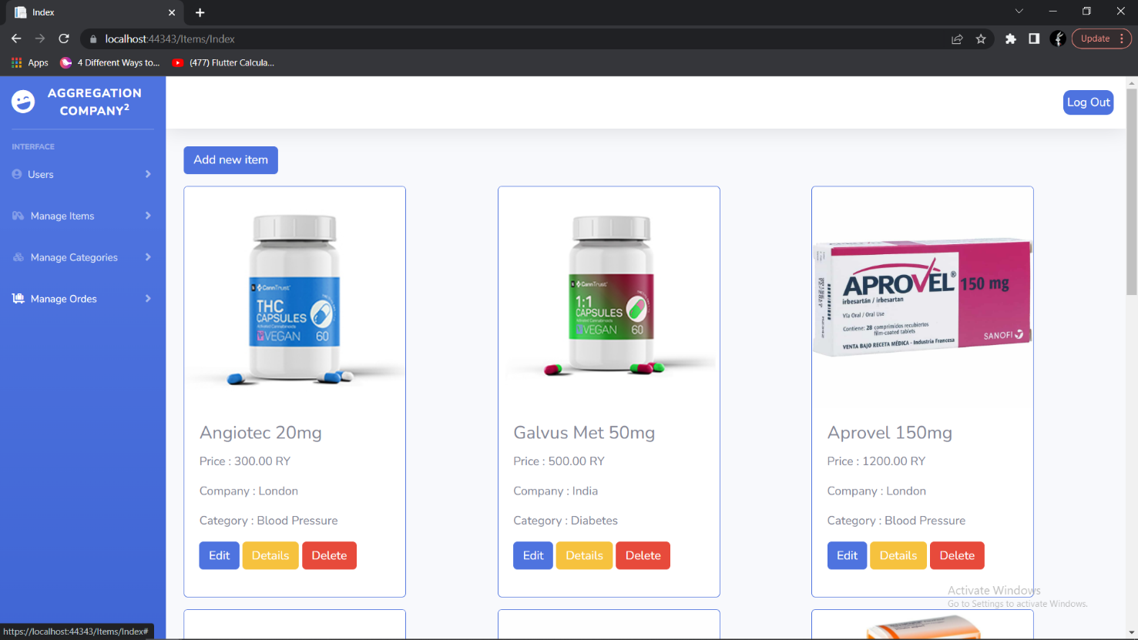

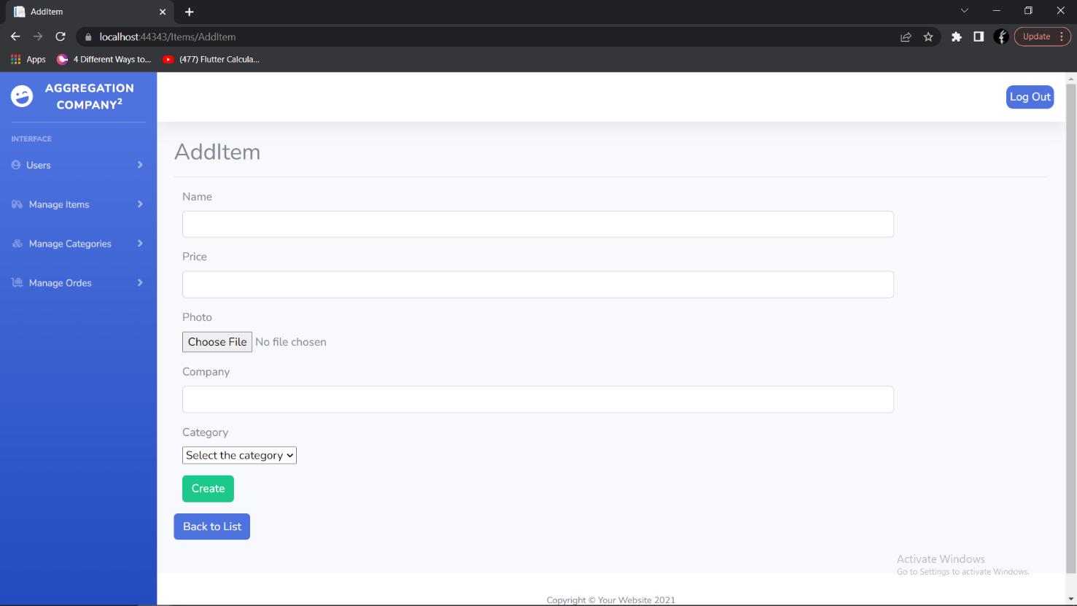Figure 4.4: Admin Item Page

Figure 4.5: Admin Add Item Page

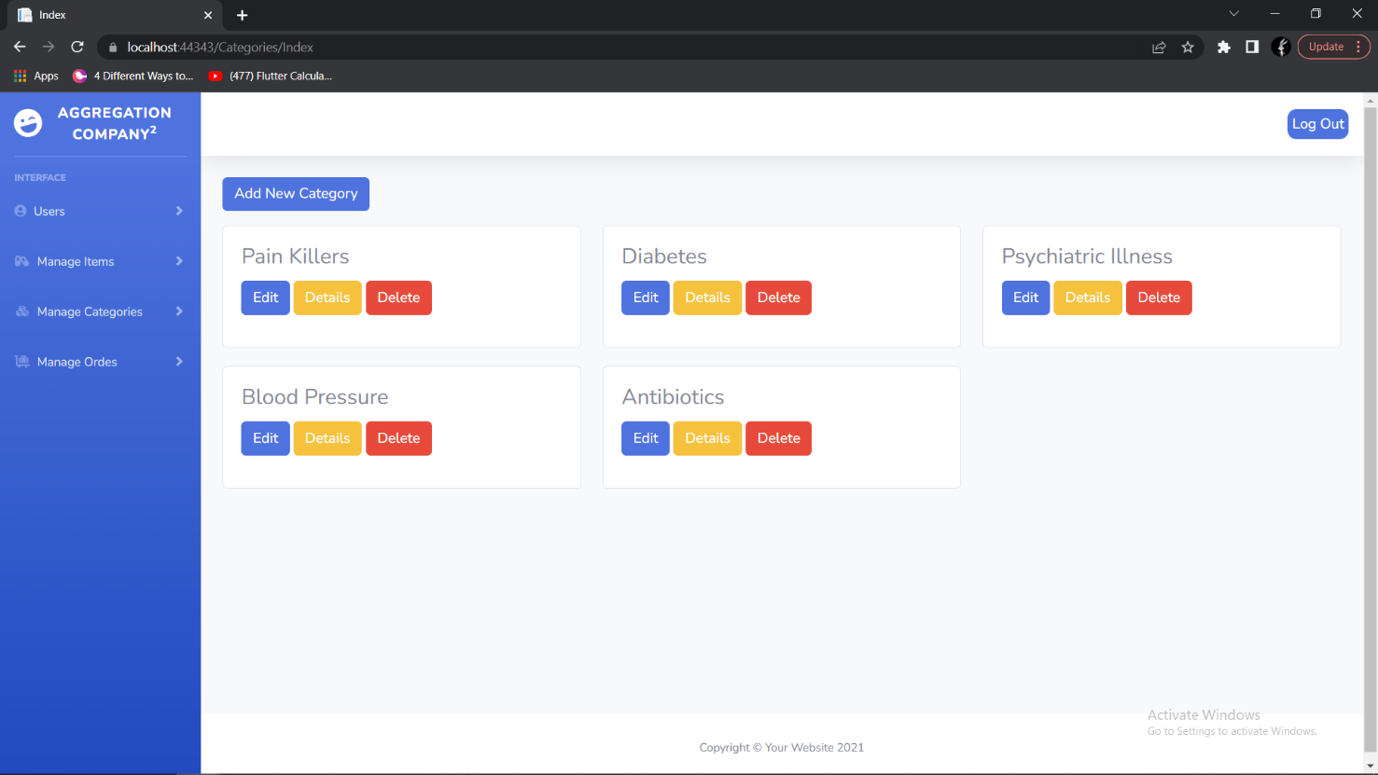

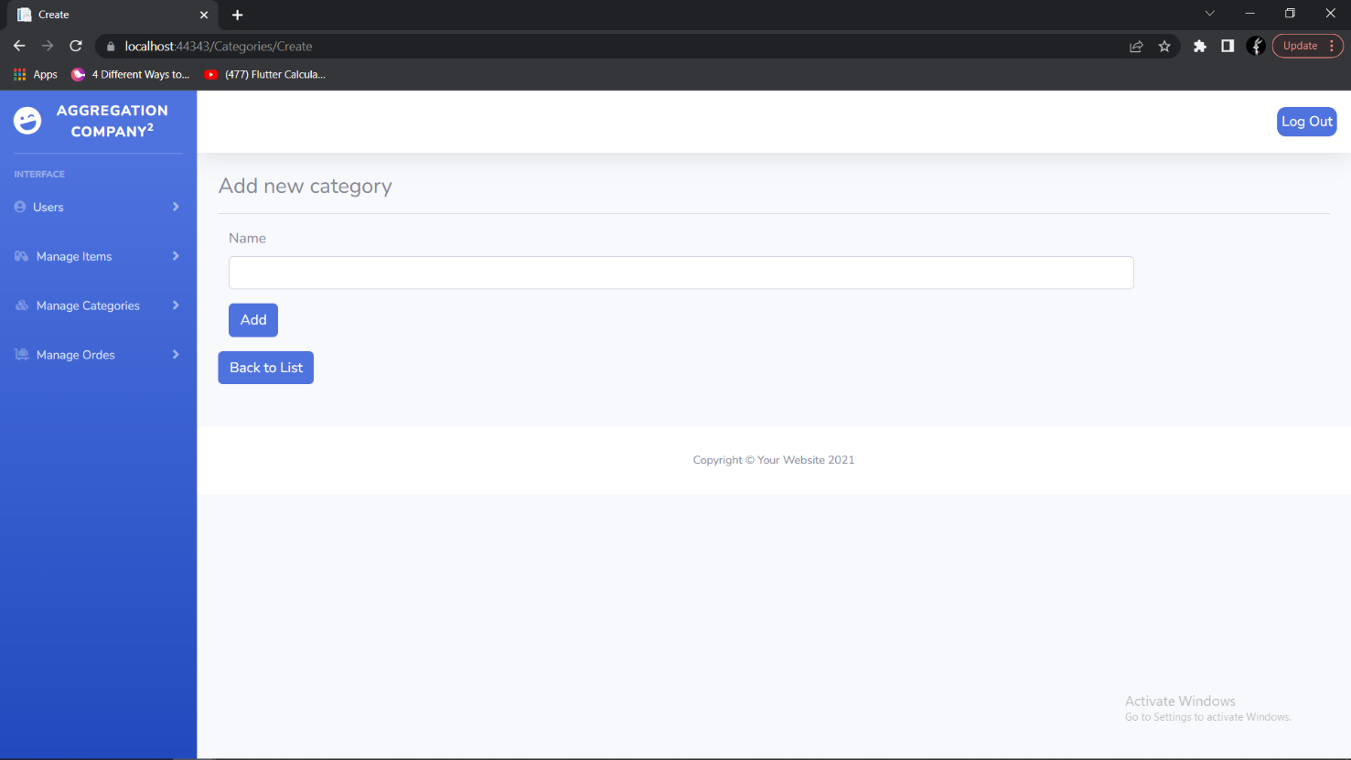Figure 4.6: Admin Category Page

Figure 4.7: Admin Add Category Page

* **Registration & Login Page:**

The registering page for be a new user in the system but they some role of that and the login page with username and password that made it.

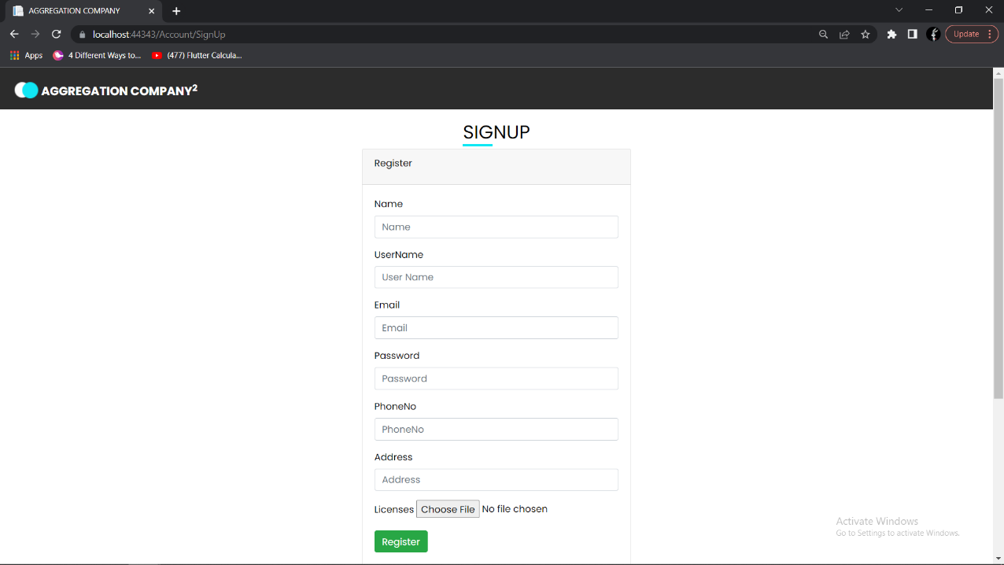

Figure 4.8: Registration Page

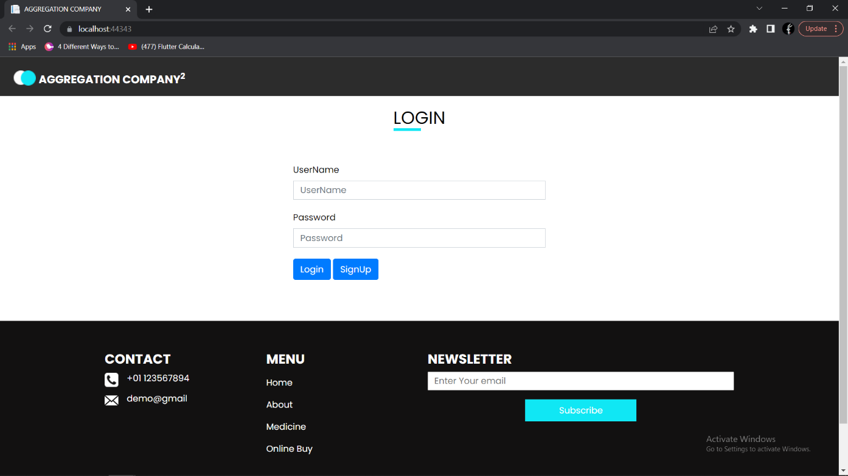

Figure 4.9: Log in Page

* 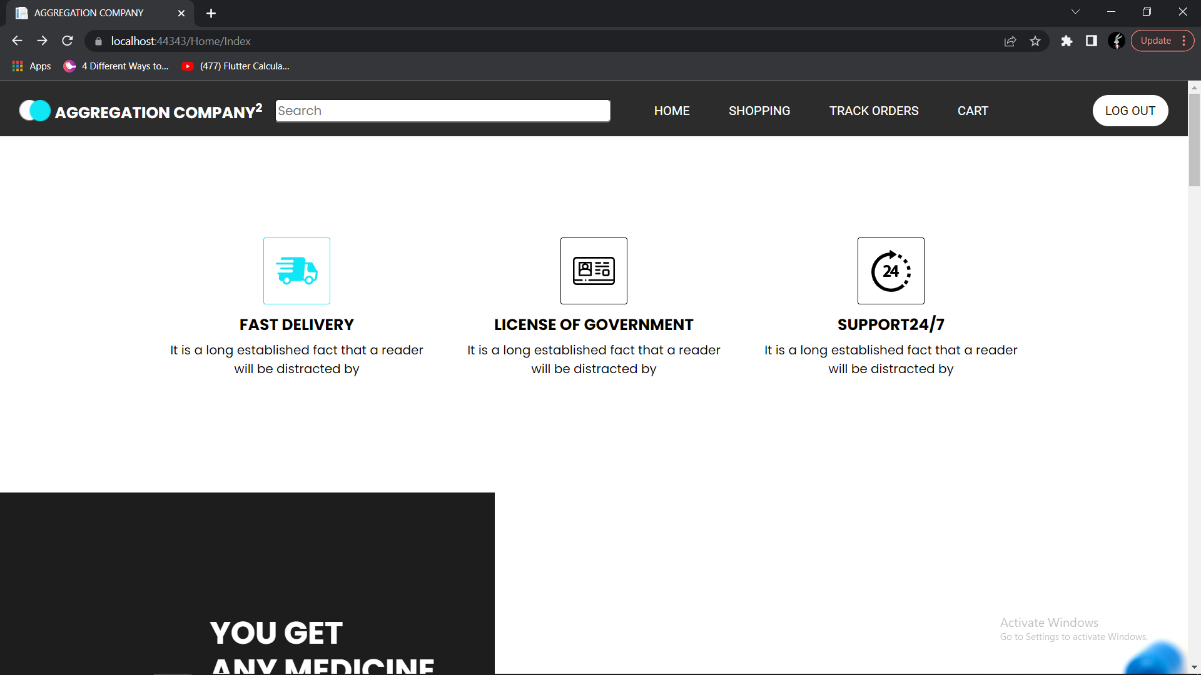**Home Page**

Figure 4.10: Home Page

* 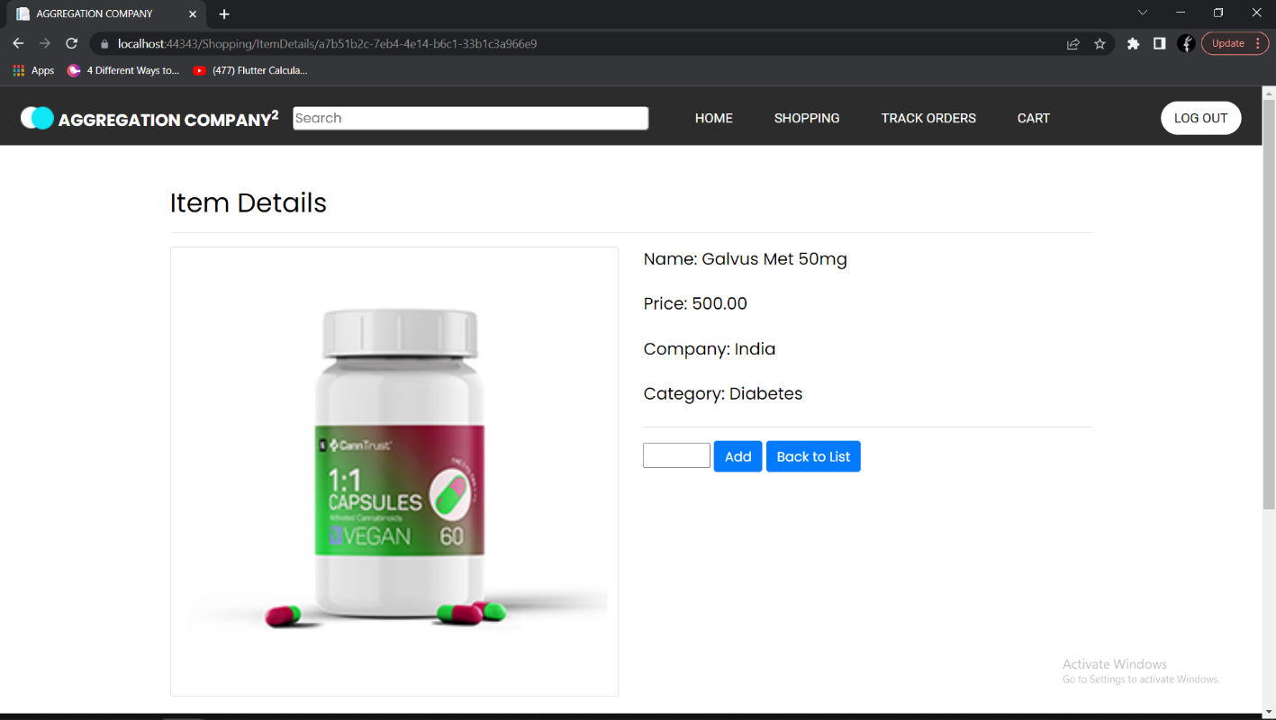**Item Details**

Figure 4.11: Item Details Page

* 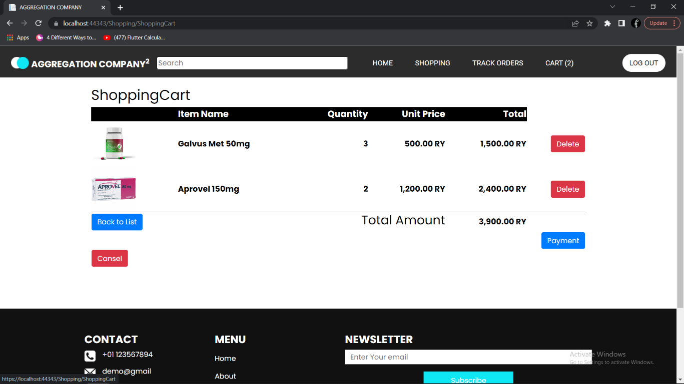**Cart Page**

Figure 4.12: Cart Page

* 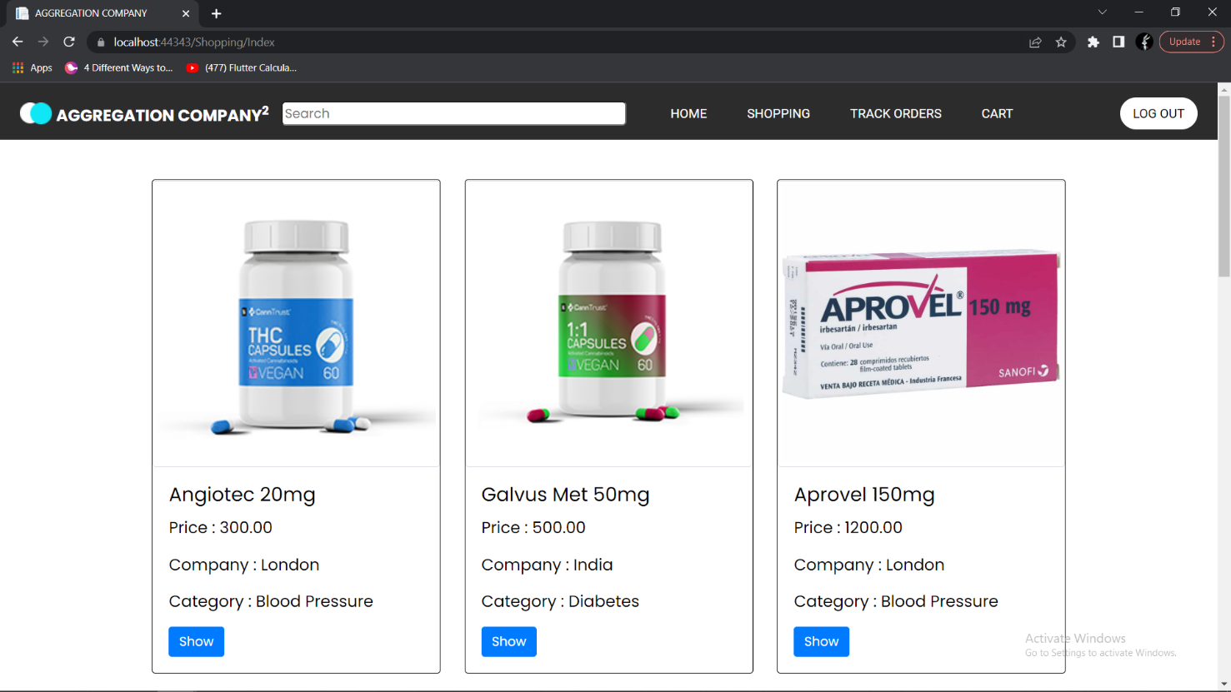 **Shopping Page**

Figure 4.13: Shopping Page

* **Track Order Page:**

The have details of order and the all order by the date that is apply and the deliverable data they will be done and the state is change to done is be successful.

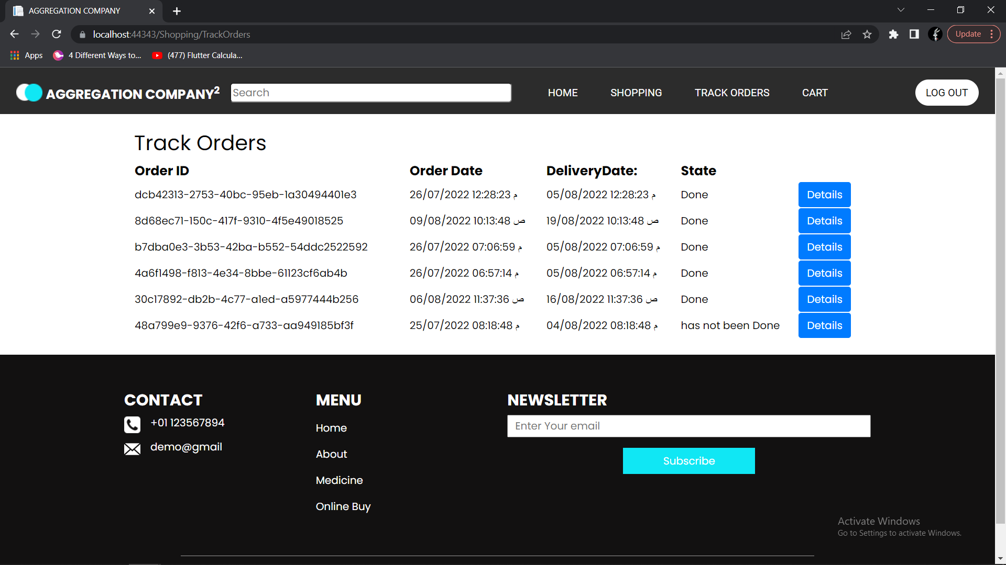

Figure 4.14: Track Order Page

**Chapter 5**

**Conclusion & Future Work**

1. **Introduction:**

The system is having more one step to be development and the conclusion of the system begin of what the objective that is hope to reach of it and the methodology of project is used and interconnecting of how objective into what extent is achieved and the result that wee reached and the suggest solution future work for the system.

1. **Conclusion:**

In our project, we focused on a set of goals to achieve them the main goal of our project is to develop a website for Assemble Companies that will be used by them to promote their products and to manage their work online , and other goals like Recording daily operation such as (Invoices (Sales – Order), The ability of tracking the orders by the customers to keep tracking about their orders whether if it's delivered or not. Launch an online store to promote the products of the company, Grow the company’s community by targeting online customers.

1. **Future Work:**

* Develop a mobile application version of the same system.
* Adding inventory brushing features.
* Financial and extra report features will be developed.

**Reference:**

[1] Abbas, M., Alhasan, A., & Hamza, U. M. (2015). Perceived Ease of Use and

Utilization of E-Learning Technologies by Academic Staff in Federal College of

Education, Zaria

[2] CPP. (2009). Scope of Contemporary Pharmacy Practice: Roles,

Responsibilities, and Functions of Pharmacists and Pharmacy Technicians

[3] Federation International Pharmaceutique. (2012). From Making Medicine to

Optimising Outcomes: The evolution of a profession 1912-2012.

[4] Mao, Y., Zhang, Y., & Zhai, S. (2008). Mobile Text Messaging for

Pharmaceutical Care in a Hospital in China.

[5] <https://www.lucidchart.com/pages/er-diagrams>

[6] <https://www.jetbrains.com/help/phpstorm/creating-diagrams.html>